**LAB#7**

**Task 2** Write a program that checks whether a number is prime or not by using if else structure and while loop.

Source code

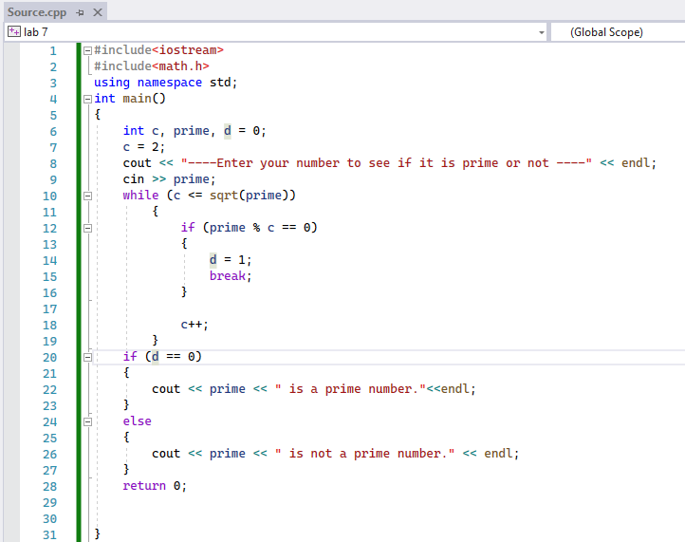

Output

